**Self-study topics.**

1. **jagged Array:**

A jagged array in C# is an array of arrays, where each element of the main array is an array itself. Unlike a multidimensional array where all rows have the same number of columns, in a jagged array, each row (array) can have a different length.

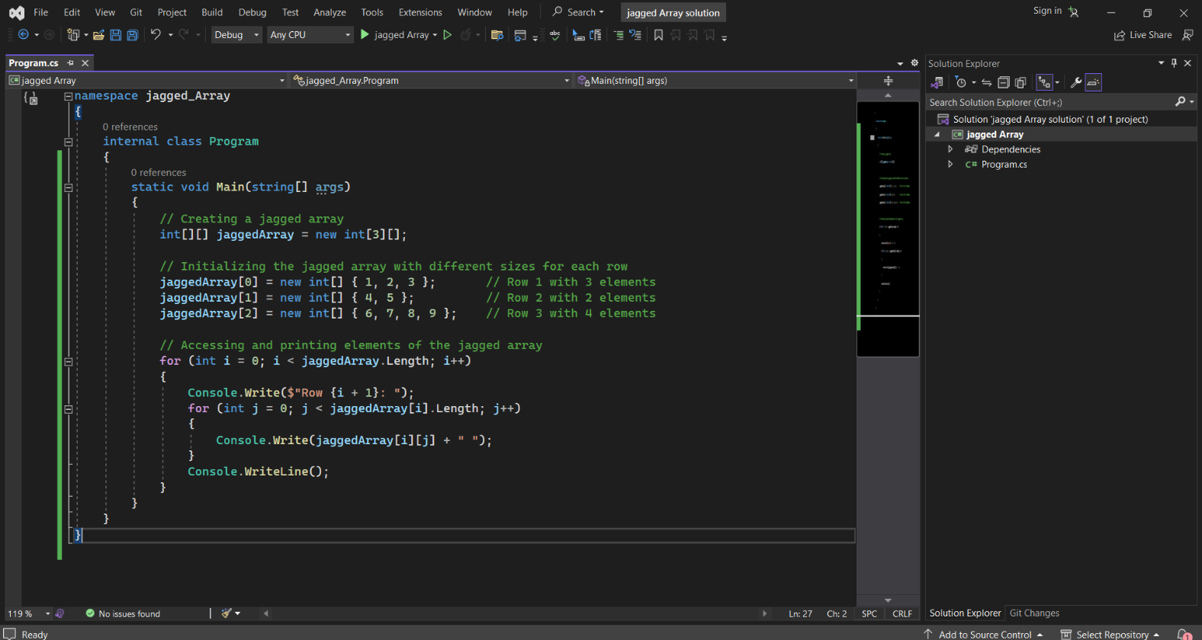**Example:**

1. **reverse slicing**

In C#, reverse slicing is not directly supported as it is in some other programming languages like Python. However, you can achieve a similar result by manipulating arrays or collections manually.

For instance, suppose you have an array of integers and you want to slice it in reverse order. Here's an example demonstrating how you can achieve this using Array.

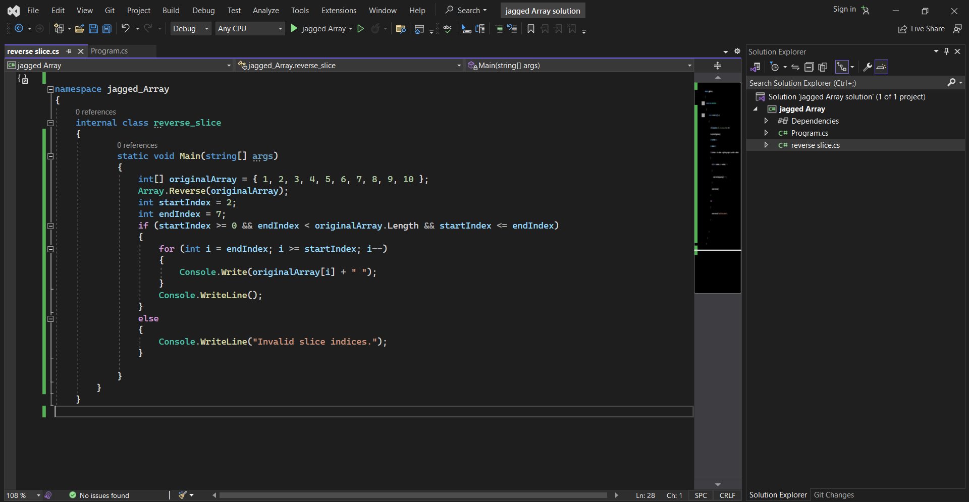**Example**: